Electric Vehicle Market Performance & Insights Project Report: Data Analytics with Tableau
Prepared by: Akshita Soni

1. Introduction

1.1 Project Overview
The electric vehicle (EV) industry is growing rapidly due to increasing awareness of environmental sustainability, technological advancements and the demand for cleaner transportation. With the growth of this industry, analyzing EV market data has become important for understanding sales performance, vehicle categories, manufacturers, pricing and battery technologies.
The project, Electric Vehicle Market Performance & Insights, focuses on analyzing electric vehicle market data using Tableau. The dataset contains 200,000 rows and 39 columns, including information about vehicle manufacturers, categories, annual sales, prices, battery technologies, manufacturing countries, driving range and other vehicle-related attributes.
Tableau Desktop is used to create visualizations, an interactive dashboard and a story to present the analysis in an understandable format. A Flask-based website is also developed to provide access to the Tableau dashboard and story.
Project Output:
- Seven Tableau visualizations.
- One interactive Tableau dashboard.
- One Tableau Story.
- A Flask-based website for displaying the project outputs.

1.2 Purpose of the Project
The main purpose of this project is to convert raw electric vehicle market data into meaningful visual information.
The project aims to:
- Analyze EV sales across different manufacturers and countries.
- Understand sales distribution across vehicle categories.
- Compare vehicle prices with annual sales.
- Study yearly EV sales trends.
- Analyze sales across different battery technologies.
- Present market information through interactive Tableau visualizations.
- Make the dashboard and story accessible through a Flask website.

1.3 Objectives
- To understand and analyze the electric vehicle market.
- To work with a large EV dataset containing 200,000 records.
- To create seven different visualizations using Tableau.
- To develop an interactive dashboard for exploring EV market information.
- To create a Tableau Story presenting important market insights.
- To integrate Tableau outputs into a Flask-based website.
- To present the analysis in a clear and understandable manner.

2. Ideation Phase

2.1 Problem Statement
The electric vehicle industry generates a large amount of information related to manufacturers, sales, prices, vehicle categories and battery technologies. When this information is available only in raw data format, it becomes difficult to understand and compare different market trends.
Users may need to examine thousands of records manually to identify patterns and differences. Therefore, a visual and interactive solution is required to make EV market information easier to explore.
This project addresses the problem by using Tableau to create seven visualizations, an interactive dashboard and a story that help users understand different aspects of EV market performance.

2.2 Target Users

User Group | Requirement
EV Market Analysts | Compare EV sales, prices and manufacturer performance.
Automotive Researchers | Study vehicle categories, battery technologies and market trends.
Students | Understand EV market data through visualizations.
Business Decision-Makers | Explore market patterns and compare available information.
EV Enthusiasts | Gain a better understanding of the electric vehicle industry.

2.3 Brainstorming
During the ideation phase, different aspects of electric vehicle market analysis were identified.
- Sales Analysis: Study EV sales across manufacturers and countries.
- Category Analysis: Compare sales across different vehicle categories.
- Price Analysis: Explore the relationship between vehicle prices and annual sales.
- Year-wise Analysis: Understand changes in EV sales over different years.
- Battery Technology Analysis: Compare sales across different battery technologies.
- Vehicle Attributes: Explore driving range and other available vehicle specifications.
Selected Solution: A Tableau-based data analytics project containing seven visualizations, an interactive dashboard and a story, integrated with a Flask website.

3. Requirement Analysis

3.1 Customer Journey Map

Stage | User Action | Dashboard Support
Awareness | Opens the project website or Tableau dashboard. | Project overview and dashboard introduction.
Exploration | Selects different categories or manufacturers. | Interactive filters and visualizations.
Analysis | Examines sales, prices and vehicle information. | Seven Tableau visualizations.
Comparison | Compares different manufacturers, countries and categories. | Charts, labels and tooltips.
Understanding | Identifies patterns and important observations. | Tableau dashboard and story.
Sharing | Shares the project with others. | Published Tableau views and Flask website.

3.2 Functional Requirements
The functional requirements describe the operations that the project should perform.
- The system should display EV market information through visualizations.
- It should present sales information across different manufacturers and countries.
- It should display sales distribution across vehicle categories.
- It should allow users to examine price and annual sales relationships.
- It should present yearly sales trends.
- It should provide battery technology comparisons.
- It should combine the visualizations into an interactive dashboard.
- It should provide a Tableau Story for presenting market insights.
- It should provide access to the dashboard and story through a Flask website.

3.3 Non-Functional Requirements
- The dashboard should be easy to understand and navigate.
- Visualizations should have clear titles, labels and legends.
- The website should display the project outputs properly.
- The system should handle the available dataset efficiently.
- The project should provide a user-friendly experience.
- The visualizations should be arranged in an organized manner.

3.4 Data Flow
The overall data flow of the project is:
EV Dataset (CSV) → Tableau Data Connection → Data Inspection and Preparation → Seven Worksheets / Visualizations → Tableau Dashboard and Story → Flask Website Integration → Final Project Output
The dataset is connected directly to Tableau for analysis. The completed Tableau outputs are then integrated into the Flask website.

3.5 Technology Stack
Layer | Tool / Technology | Purpose
Data Source | EV Market Dataset (CSV) | Provides electric vehicle market information.
Data Analysis | Tableau Desktop | Analyzes and organizes the dataset.
Data Visualization | Tableau Desktop | Creates seven visualizations.
Dashboard Development | Tableau | Combines visualizations into one dashboard.
Story Development | Tableau | Presents market insights through a story.
Website Development | Python and Flask | Creates the project website.
Publishing | Tableau Public | Publishes and shares Tableau outputs.
Documentation | Microsoft Word | Prepares the project report.

4. Project Design

4.1 Problem–Solution Fit
The main problem identified in this project is that analyzing raw EV market records requires time and effort. It can be difficult to identify sales patterns, compare manufacturers and understand differences across vehicle categories by examining individual records.
The proposed solution uses Tableau to convert the available data into seven visualizations. These visualizations are organized into an interactive dashboard and a Tableau Story.
The Flask website provides another way to access the project outputs. This approach makes the information easier to understand, explore and present.

4.2 Proposed Solution
The project solution includes the following activities:
- Connecting the EV dataset to Tableau Desktop.
- Inspecting the available dataset fields.
- Using the cleaned dataset for visualization.
- Creating seven visualizations based on different EV market aspects.
- Developing an interactive Tableau dashboard.
- Creating a Tableau Story to present the analysis.
- Integrating Tableau outputs into a Flask website.
- Testing the website and dashboard before demonstration.

4.3 Solution Architecture
The project architecture follows this sequence:

EV Market Dataset (CSV)
|
v
Tableau Data Source
|
v
Data Inspection and Preparation
|
v
Seven Tableau Worksheets
|
v
Tableau Dashboard
|
v
Tableau Story
|
v
Tableau Public
|
v
Python Flask Website
|
v
Final Project Output

The Tableau workbook is used for data visualization and analysis, while Flask provides the website interface for accessing the dashboard and story.

5. Project Planning & Scheduling

5.1 Project Planning
The project was completed individually by following different development stages, starting from problem identification and data understanding to visualization development, dashboard creation and website integration.
Phase | Activities | Output
1. Problem Identification | Identifying the need for EV market analysis. | Problem Statement
2. Data Collection | Obtaining the EV market dataset. | EV Dataset
3. Data Understanding | Connecting and inspecting the dataset in Tableau. | Tableau Data Source
4. Data Preparation | Reviewing the available fields and using the cleaned dataset. | Analysis-ready Dataset
5. Visualization Development | Creating seven different visualizations. | Seven Tableau Worksheets
6. Dashboard Development | Arranging the visualizations and adding interactive filters. | Interactive Dashboard
7. Story Development | Creating a story about the global EV manufacturing ecosystem. | Tableau Story
8. Website Development | Integrating Tableau outputs into a Flask website. | Flask Website
9. Testing and Documentation | Checking the project outputs and preparing the report. | Final Project

5.2 Project Resources

Resource Type | Description | Specification
Hardware | Computer / Laptop | Used for project development.
Memory | System RAM | Used for running Tableau and Flask.
Storage | Local Storage | Used to store the dataset and project files.
Software | Tableau Desktop | Data analysis and visualization.
Programming Language | Python | Website development.
Framework | Flask | Website integration.
Dataset | EV Market Dataset | 200,000 rows and 39 columns.

6. Functional and Performance Testing

6.1 Functional Testing
Functional testing was performed to check whether the project components worked as expected.
S.No | Test Case | Expected Result | Status
1 | Dataset Connection | Dataset should connect successfully to Tableau. | Pass
2 | Sales by Manufacturer | Manufacturer-wise sales should be displayed correctly. | Pass
3 | Sales by Countries | Country-wise sales should be represented visually. | Pass
4 | Price vs Annual Sales | Scatter plot should display price and annual sales information. | Pass
5 | Sales by Category | Category-wise sales distribution should be displayed. | Pass
6 | Year-wise Sales Analysis | Yearly sales trends should be displayed. | Pass
7 | Battery Technology Analysis | Annual sales across battery technologies should be compared. | Pass
8 | Interactive Dashboard | Dashboard should display the visualizations and respond to available filters. | Pass
9 | Tableau Story | Story should present the EV manufacturing ecosystem. | Pass
10 | Flask Website | Website should provide access to the Tableau project outputs. | Pass
The statuses above reflect the completed components discussed in your project work. Keep Pass only for components you personally tested successfully.

6.2 Performance Testing
Performance testing was conducted to observe how Tableau handled the available dataset and how the visualizations responded during analysis.
Parameter | Description / Result
Amount of Data Rendered | 200,000 rows and 39 columns.
Utilization of Filters | Manufacturer, Category and Manufacturing Country filters.
Calculated Fields | 1 confirmed calculated field.
Number of Visualizations | 7
Dashboard Performance | Visualizations loaded and responded during filter usage.
Website Functionality | Flask website displayed the project sections and Tableau outputs.

6.3 Testing Outcome
The project components were checked after development. The Tableau visualizations, dashboard and story were reviewed, and the Flask website was tested to ensure that the project outputs could be accessed.
The available dataset was successfully used for creating the visualizations and presenting EV market information.

7. Results and Discussion

7.1 Project Output
The project successfully developed a Tableau-based EV market analysis solution containing seven visualizations, an interactive dashboard and a Tableau Story. A Flask website was also developed to provide access to the project outputs.
The seven visualizations cover different aspects of EV market performance.

7.2 Seven Visualizations

S.No | Visualization Name | Chart Type | Purpose
1 | Sales by Manufacturer | Rectangle-based Plot | Compares EV sales across manufacturers.
2 | Sales by Countries | Country-wise Visualization | Displays EV sales across different countries.
3 | Price vs Annual Sales | Scatter Plot | Examines the relationship between vehicle prices and annual sales.
4 | Sales by Category | Donut Chart | Displays the distribution of sales across vehicle categories.
5 | Year-wise Sales Analysis | Line Chart | Shows changes in EV sales over different years.
6 | Annual Sales by Battery Technology | Bar Chart | Compares annual sales across battery technologies.
7 | Additional EV Market Visualization | Replace with actual chart type | Presents another aspect of EV market performance.
Important: You have confirmed six visualization names so far. Enter the actual seventh worksheet name and chart type before submitting. The rectangle-based plot is described as a rectangle chart rather than assuming a particular Tableau chart subtype.

7.3 Interactive Dashboard
The Tableau dashboard combines all seven visualizations into one organized interface.
The dashboard allows users to:
- View different aspects of EV market performance in one place.
- Compare sales across manufacturers.
- Explore sales across vehicle categories.
- Examine country-wise EV market information.
- Use filters such as Manufacturer, Category and Manufacturing Country.
- Understand market patterns through multiple charts.

7.4 EV Market Story
A Tableau Story was created to present insights about the global EV manufacturing ecosystem.
The story focuses on:
- Worldwide distribution of EV manufacturing facilities.
- Countries involved in EV production.
- Manufacturing density across regions.
- Emerging EV production hubs.
- Geographic concentration of the EV manufacturing ecosystem.
The story helps present the analysis in a structured and understandable sequence.

7.5 Flask Website
A website was developed using Python and the Flask framework to provide access to the Tableau dashboard and story.
The website includes:
- Project title and introduction.
- EV Market Dashboard section.
- EV Market Story section.
- Links or embedded Tableau content for accessing the project outputs.
The Flask website provides a simple interface for presenting the completed project.

7.6 Key Observations
The project provides different ways to explore EV market information. The manufacturer and country visualizations help compare market distribution, while the scatter plot helps examine the relationship between price and annual sales.
The category and battery technology charts provide additional perspectives on EV sales. The line chart helps users explore changes over time.
Exact numerical findings and leading categories should be reported using the values displayed in the final Tableau dashboard rather than estimated values.

8. Advantages and Limitations

8.1 Advantages
- Makes large EV datasets easier to understand.
- Provides seven different visual perspectives of the EV market.
- Combines multiple visualizations into one interactive dashboard.
- Helps compare manufacturers, countries and vehicle categories.
- Provides a structured Tableau Story.
- Uses Flask to make the project outputs accessible through a website.
- Helps communicate data insights in a clear visual format.

8.2 Limitations
- The analysis depends on the accuracy and completeness of the available dataset.
- The dataset represents the information available at the time of collection.
- The project does not automatically provide real-time EV market updates.
- The analysis is limited to the fields available in the dataset.
- The current website is developed primarily for project demonstration and may require additional improvements for large-scale usage.

9. Conclusion
The project Electric Vehicle Market Performance & Insights demonstrates the use of data analytics and visualization techniques to understand the electric vehicle industry.
Using a dataset containing 200,000 rows and 39 columns, the project presents different aspects of EV market performance through seven Tableau visualizations.
An interactive dashboard was developed to bring the visualizations together, while a Tableau Story was created to present insights about the global EV manufacturing ecosystem.
Additionally, a Flask-based website was developed to provide access to the Tableau dashboard and story.
Overall, the project helped demonstrate how data visualization can transform raw information into meaningful insights and make complex datasets easier to understand and analyze.

10. Future Scope
The project can be enhanced in the future through the following improvements:
- Updated Dataset: Integrate newer EV market data to keep the analysis updated.
- Advanced Analytics: Include additional statistical analysis of EV market performance.
- Sales Prediction: Explore forecasting techniques to estimate future EV sales when sufficient historical data is available.
- Improved Dashboard: Add more interactive filters and improve dashboard navigation.
- Website Enhancement: Improve the Flask website design and functionality.
- Cloud Deployment: Deploy the website on a suitable hosting platform for wider accessibility.
- Additional Visualizations: Include more charts based on additional available EV market information.
These improvements can make the project more informative, scalable and useful for future EV market analysis.

11. Appendix

11.1 Project Resources
Resource | Details
Dataset | EV Market Dataset (CSV)
Dataset Size | 200,000 Rows and 38 Columns
Tableau Workbook | Workbook containing seven visualizations, dashboard and story.
Website Source Code | Python and Flask project files.
Dashboard Link | https://public.tableau.com/app/profile/akshita.soni4795/viz/EV-market_insights/EVSalesDashboard?publish=yes
Story Link | https://public.tableau.com/app/profile/akshita.soni4795/viz/EV-market_insights/ElectricVehicleMarketAnalysi?publish=yes
Website Link | https://electric-vehicle-market-performance-fbzx.onrender.com

11.2 Screenshots
Complete Tableau Dashboard.
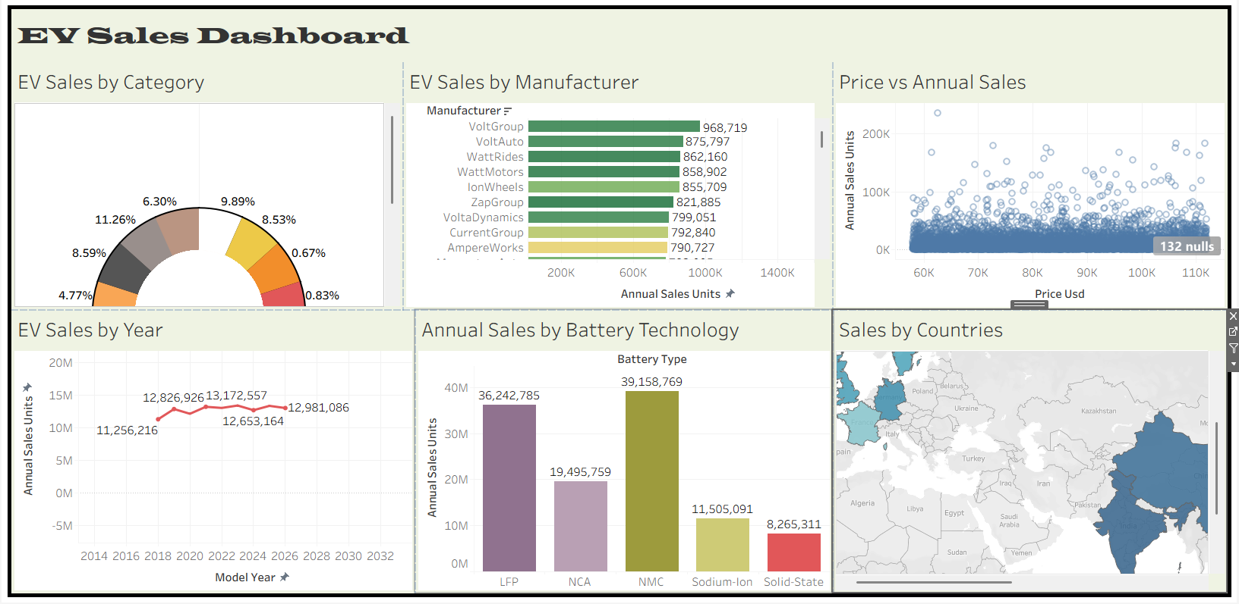

Tableau Story.
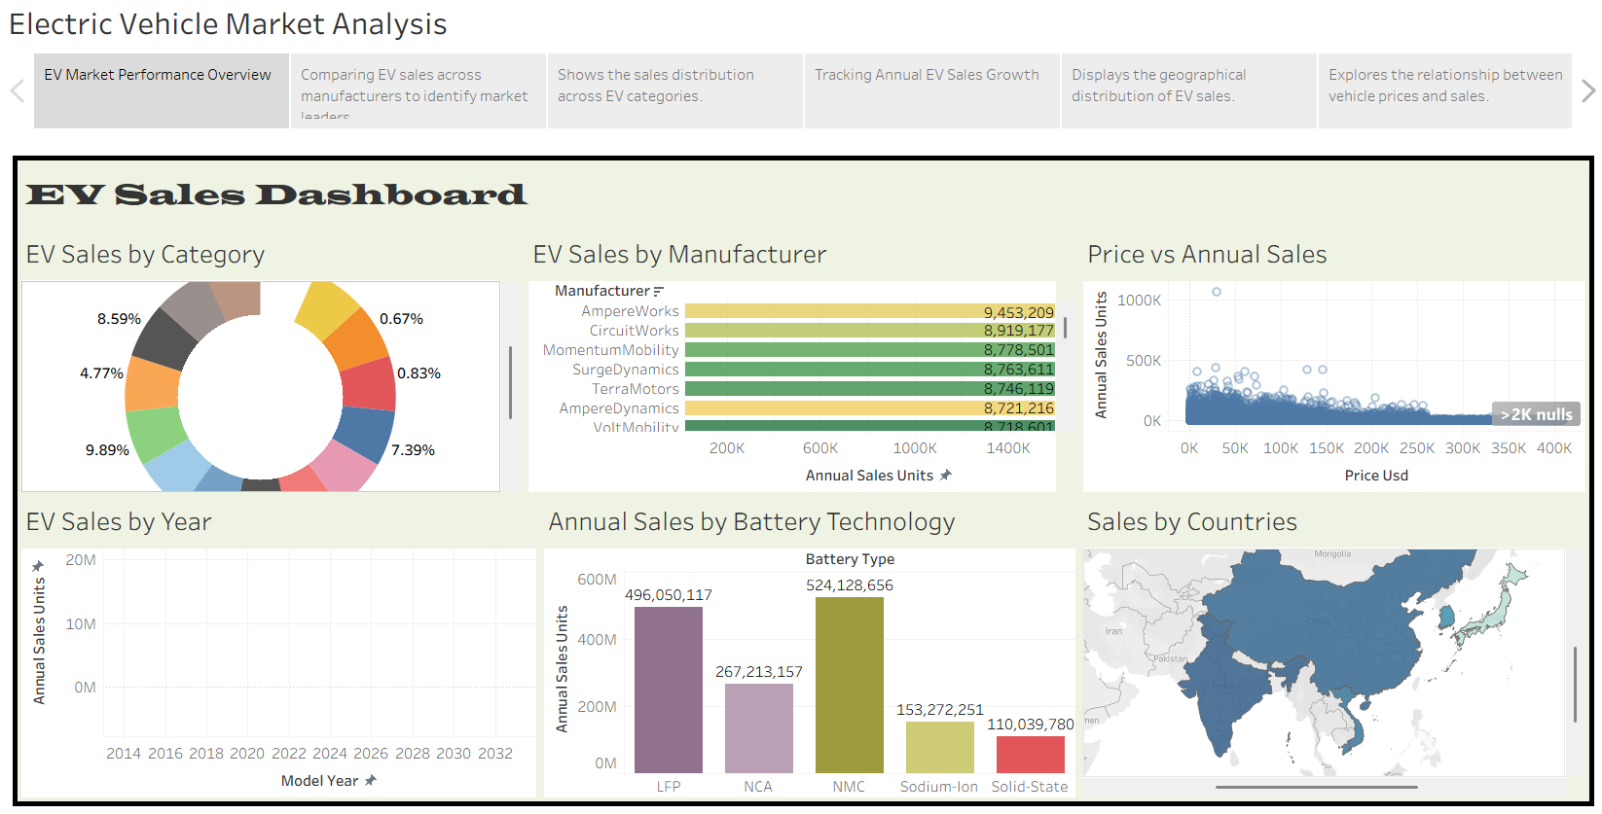

Flask Website homepage.


